PMO Email: PMO@uconn.onmicrosoft.com Website: https://pmo.its.uconn.edu/

Lessons Learned Surveys for Projects
You can now use Microsoft Forms for creating Lessons Learned Surveys at the end of a project. Just follow the procedure below.
However, if you would rather hold a group meeting to collect the data, you can use the following template instead - ITS PMO - Lessons Learned Template.xlsx

Getting started
- Go to the ITS PMO Team’s Forms page to access the Lessons Learned Template by clicking the link below.
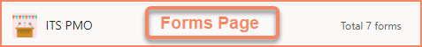
- Locate the Lessons Learned Survey (Template) and make a copy.
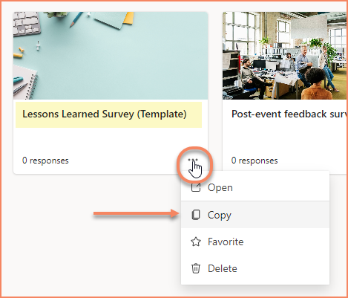
- Start creating the survey.
If you need help… we created a document to help you out.
Using Forms for Creating Surveys.docx
Have Fun!

